Professional Dairy Producers® is a dairy producer-led organization founded by dairy farmers, led by dairy farmers and serving dairy farmers.
PDPW bylaws allow one vote per dairy farm membership. Since the PDPW Board of Directors has three available positions, each PDPW dairy producer member can vote for up to three individuals.

Cast your ballot in one of two manners: 1) at the 2023 PDPW Business Conference, March 15-16, in Wisconsin Dells, Wis., or 2) mail your marked ballot to PDPW, using the enclosed envelope. Mail-in ballots must be postmarked by Monday, February 20, 2023. All votes will be kept confidential and counted by the PDPW ballot clerks at the 2023 PDPW Business Conference. All votes must be in by 1:00 p.m. on Thursday, March 16.

If you have questions about the process, candidates or your ballot, please call PDPW at 800-947-7379.

PDPW Board of Directors candidates: Select three (3)

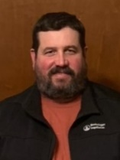
Scott Brenner co-owns Hunter Haven Farms in Pearl City, Il. The farm consists of 1,000 dairy cows and 1,650 acres of farmed cropland. Before becoming a co-owner, Brenner worked as the herdsman at Hunter Haven Farms for over 15 years. Brenner has served for over 10 years on the Stephenson Fair board and the Stephenson County Farm Bureau board of directors for five years. Brenner is an enthusiastic advocate for agriculture and consumer education; their farm has hosted many tours throughout the years. Brenner and his wife, Jennifer, have 5 children.

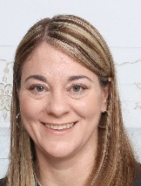
Patty Dolph of Lake Mills, Wis., farms with her husband, Chet, and in-laws, Pat and Don Dolph. The farm milks 500 dairy cows and crops 1,000 acres of land. Patty’s role is the manager of the milking operation which includes the dairy herd, young stock and employees. She attended UW-Madison and earned an Animal Science degree. The farm focuses on cow comfort and animal health and has earned many milk quality awards. She would bring a hands-on perspective of the dairy business.

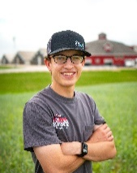
Jordan Ebert of Algoma, Wis., is part of the 7th generation in agriculture on his family’s farm. Ebert Enterprises is a dairy, beef, and cropping operation owned by his parents, Randy and Renee. The farm runs 8,500 acres, raises all youngstock, milks 4,200 cows, and raises 2,000 head of beef crosses with 90 valued employees. The family has diversified with a retail and wholesale meat products business, beef harvest facility, and a farm-to-table minded restaurant. Jordan attended UW-Madison and worked in industry at ABS Global before returning to the family business.

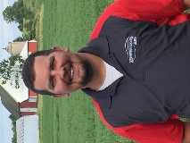
JJ Pagel of Kewaunee, Wis., is a third-generation farmer who owns and operates Pagel’s Ponderosa Dairy with his sister Jamie and brother Bryan. JJ attended UW Madison Farm and Industry Short Course and Cornell Dairy Executive Program. Today, the Pagel family milks just over 10,000 cows at 5 sites and farms 15,000 acres. They have on-site processing for farmstead cheeses that are sold at their retail store in nearby Luxemburg, Wis. JJ and his wife Chase have four children and are active members of the Kewaunee County Dairy Promotions, coaching and community activities.

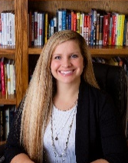
Laura Raatz of Oconto Falls, Wis., and her husband Tyler are part owners of Wagner Farms with her brother, Shawn, and parents Hank and Pam Wagner. She graduated from UW-Marinette with an associate degree and a passion to go back to the farm where she is now herd manager. In this role, she focuses on taking animal health and comfort to the next level. Wagner Farms has 950 cows and crops about 1,500 acres. Laura is involved in four other businesses including leadership training with her dad where they just authored their first book together.

