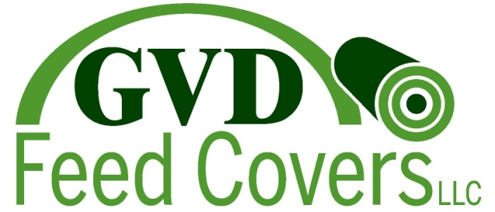

GVD Feed Covers is a small company dedicated to providing the best quality feed covers to producers of all shapes and sizes at an affordable price.

GVD Feed Covers was started by our dairy farm which provided feed covers to our neighbors allowing everyone a better pricing and the convenience of custom sizing. Through numerous trials, Raven Industries was the only company to provide the highest quality oxygen barrier feed cover, FeedFresh. With exceptional strength and extremely low oxygen transmission rate (OTR) of 3.5, FeedFresh has been widely used by many producers to increase their bottom lines by saving feed!

But maybe you’re not ready for FeedFresh, then look into one of our lines. Maybe a 6 mil reinforced black on white product referred to as a Duraskrim line, or even our 5 mil FeedPro line all made right here in the United States at a company where quality and consistency is synonymous with their name, Raven Industries.
Since our beginning we have tried to be flexible with the sizing so as to eliminate wasted excess feed covers, which lead us to rewinding rolls of plastic to meet the customized lengths required for each operation. With the three different types of feed covers, we can provide options for all sizes. After all, sometimes One Size Doesn’t Fit All!
Plan on us to provide the best information and highest quality covers for your operation. Because good feed doesn’t just happen, it’s PLANNED!

