

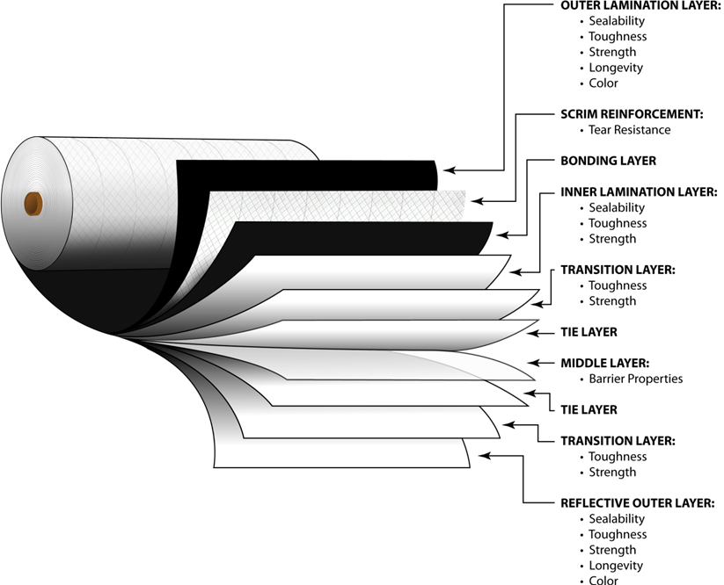

This would be what the FeedFresh would be if you were able to “slice” it into each individual layer.

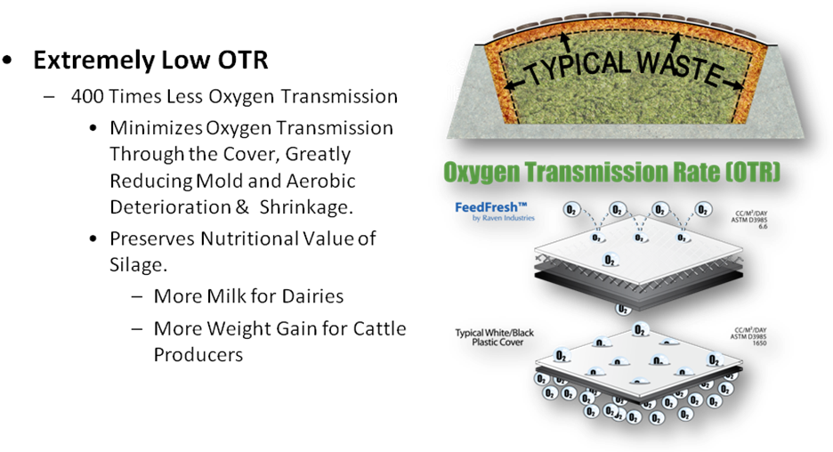

GVD Feed Covers, LLC.
Email : gvdfeedcovers@gmail.com
Phone : 888-853-2501

